***Kosta Nikopoulos***

***Lab 6***

***UNIX***

1.

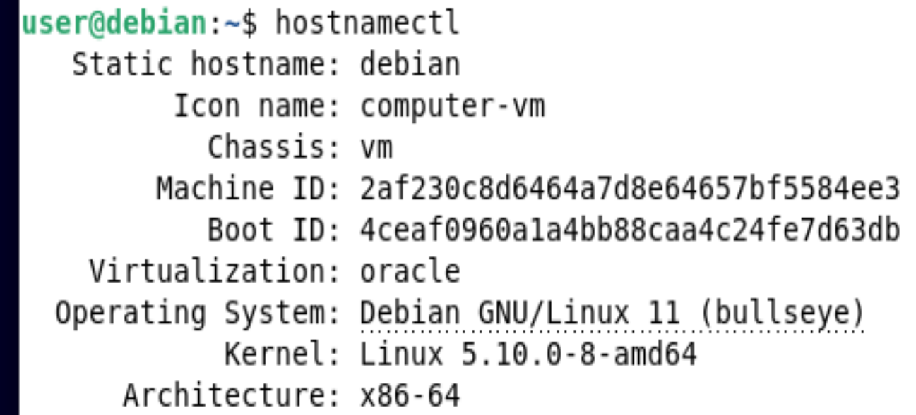

2.

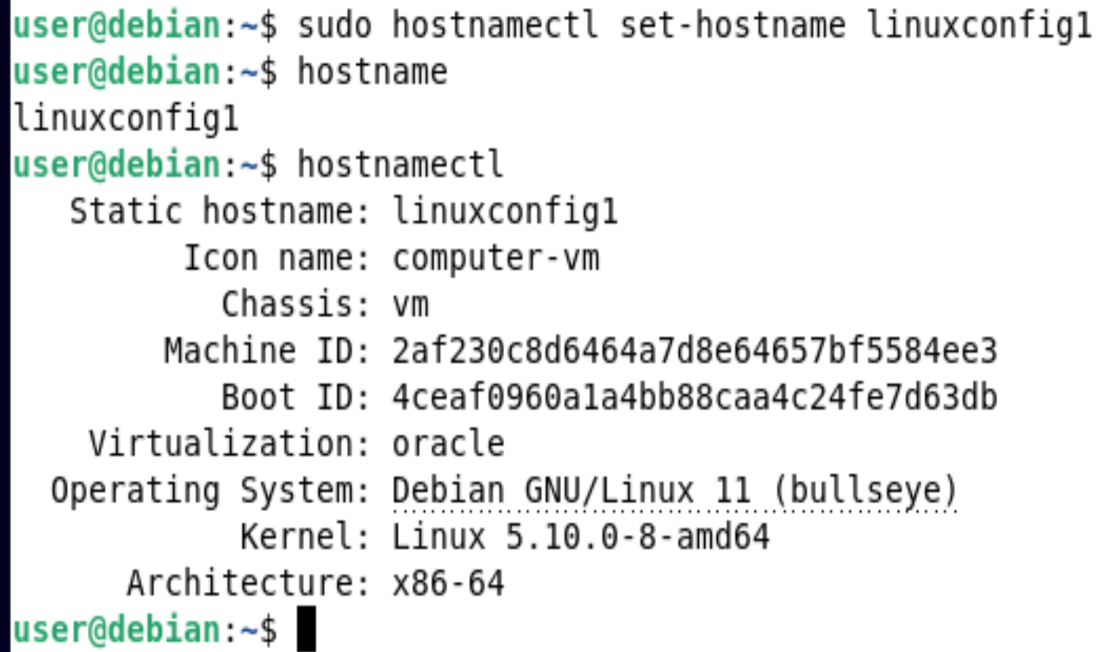

3.

Passwd

sudo passwd

su user1

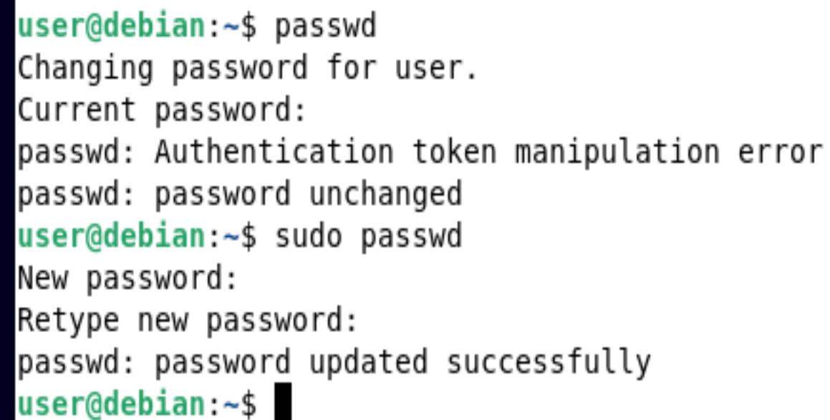

4.

Top command

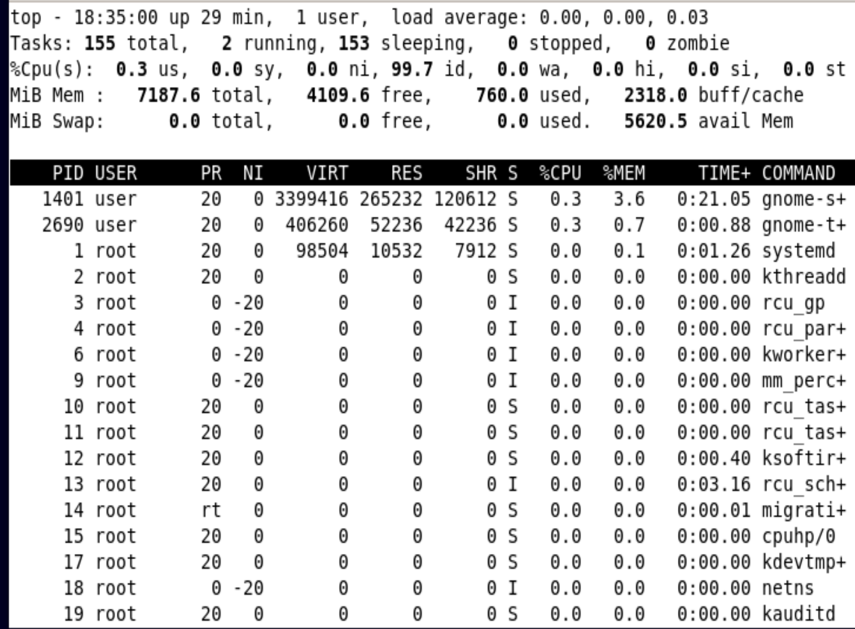

5.

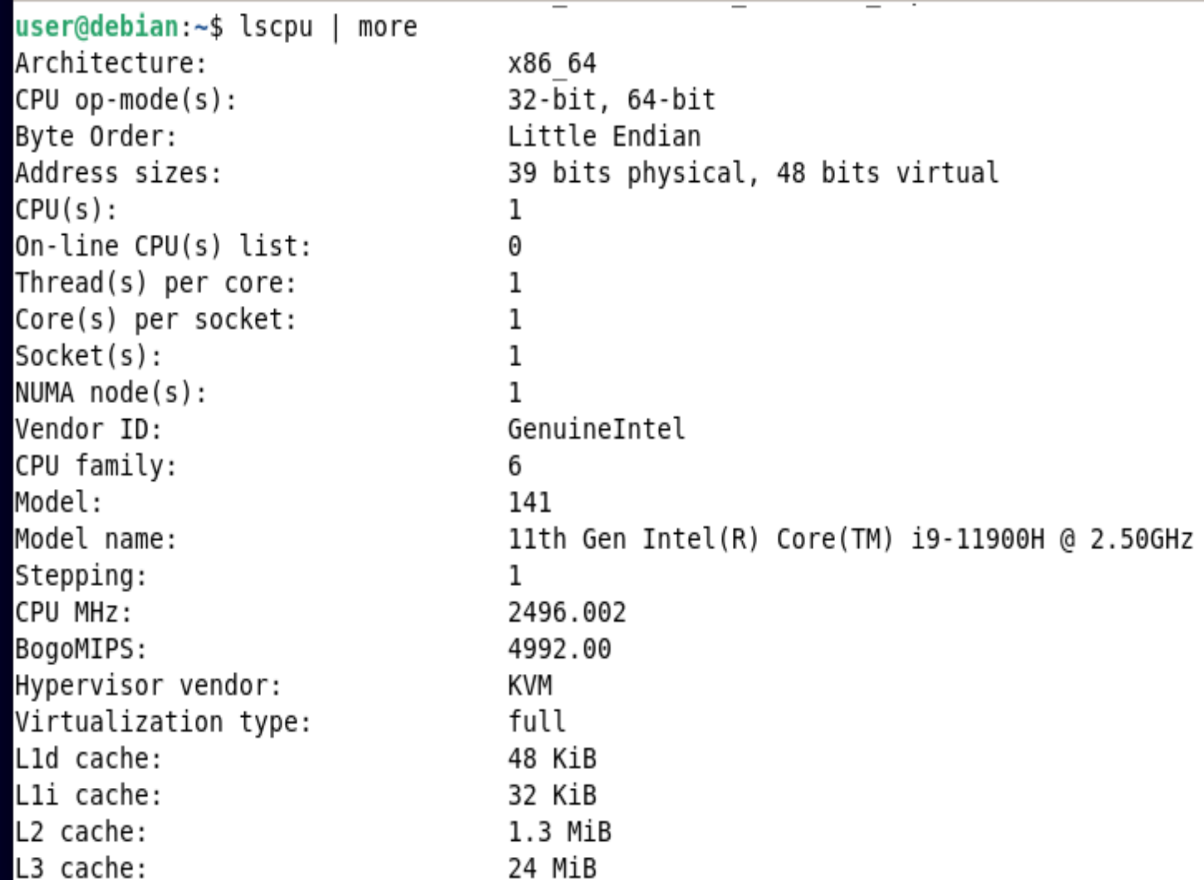

6.

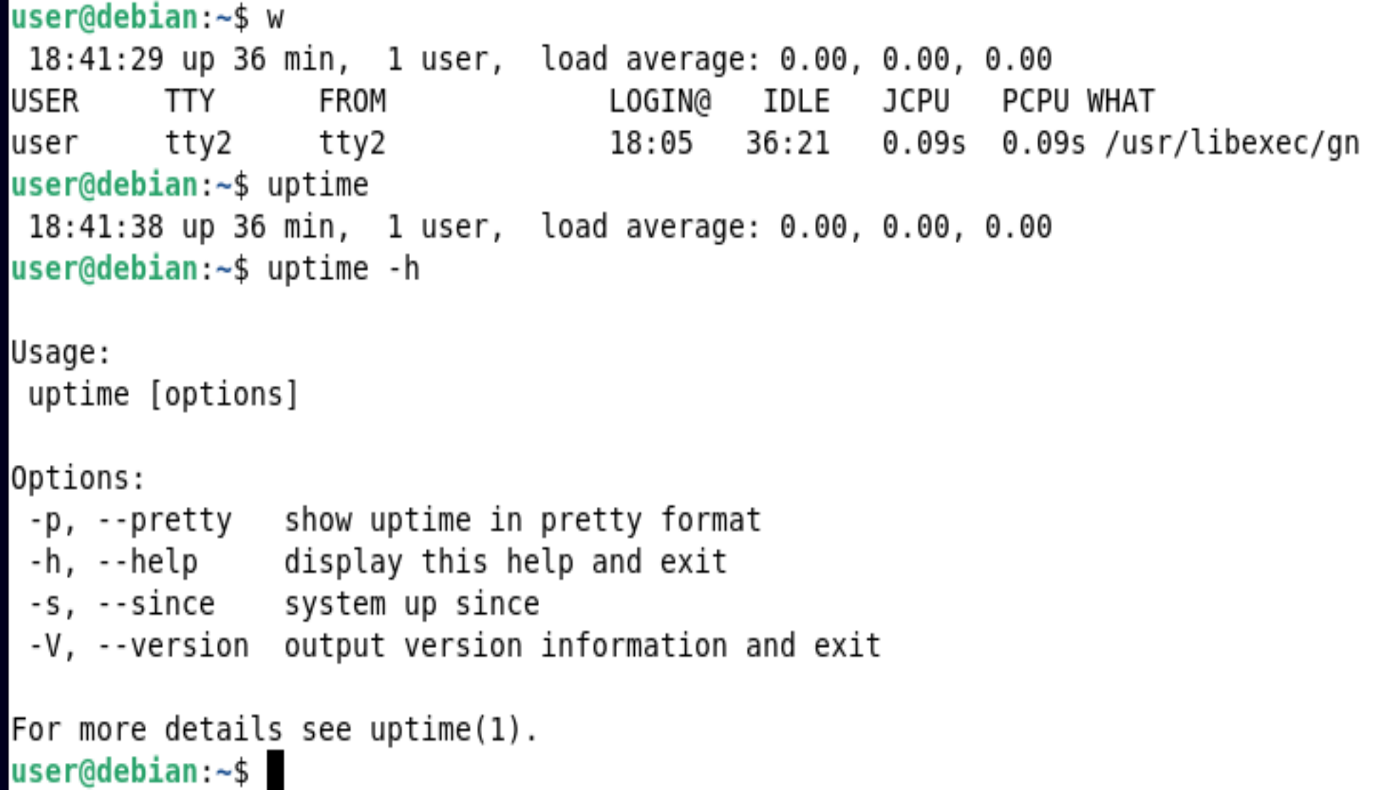

7.

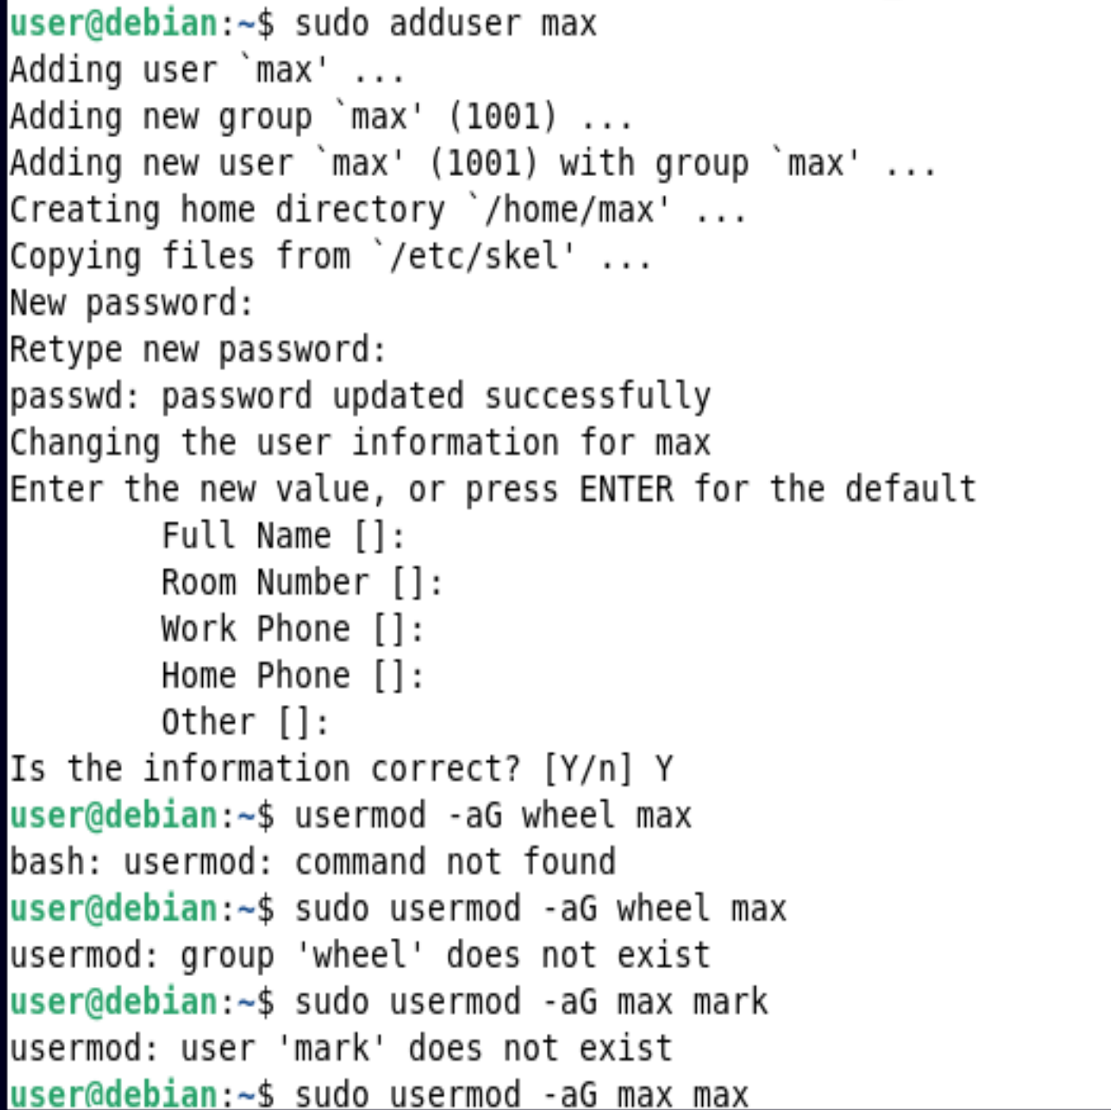 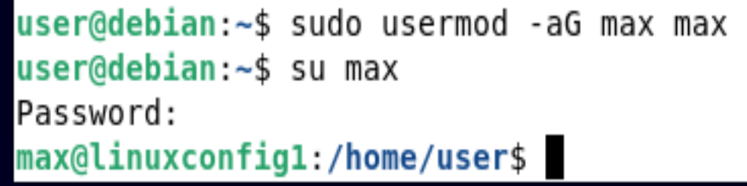

8.

Su stands for substitute user – you can switch to root without an argument

Sudo stands for substitute user do – you are giving the system a command to execute.

9.

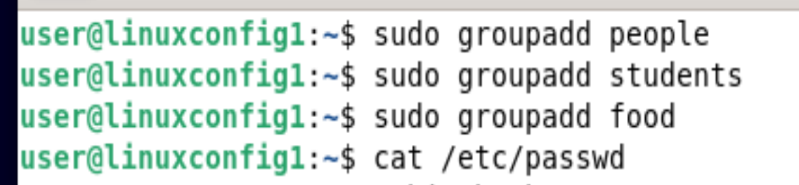

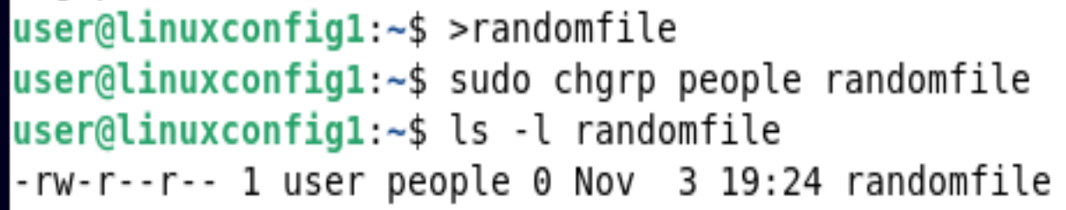



10.

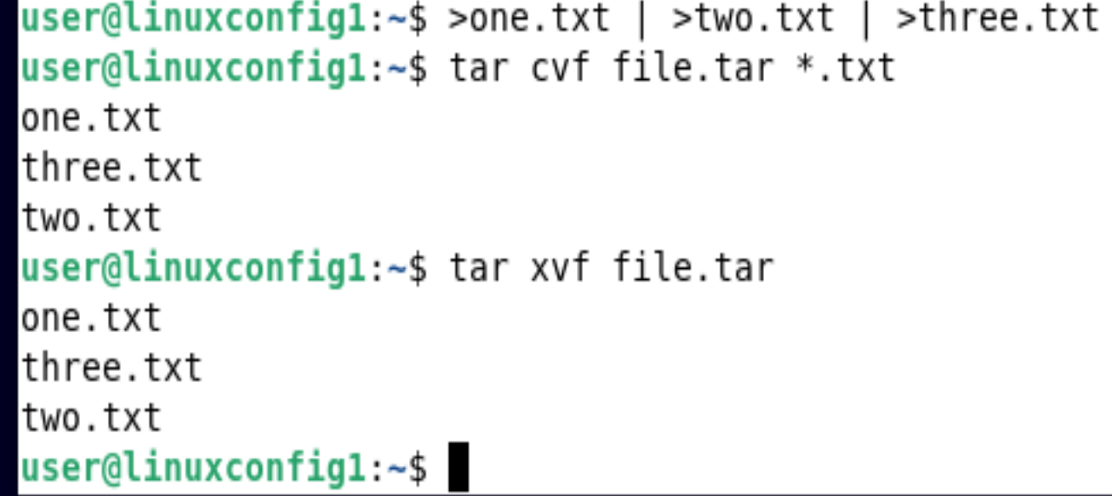

11.

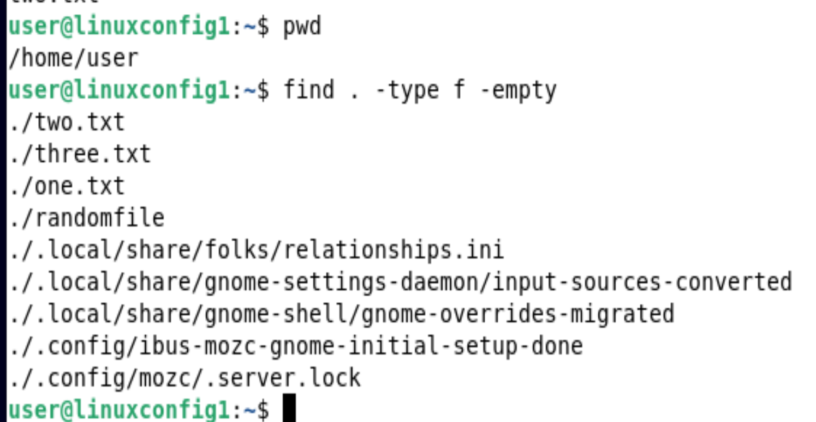

12.

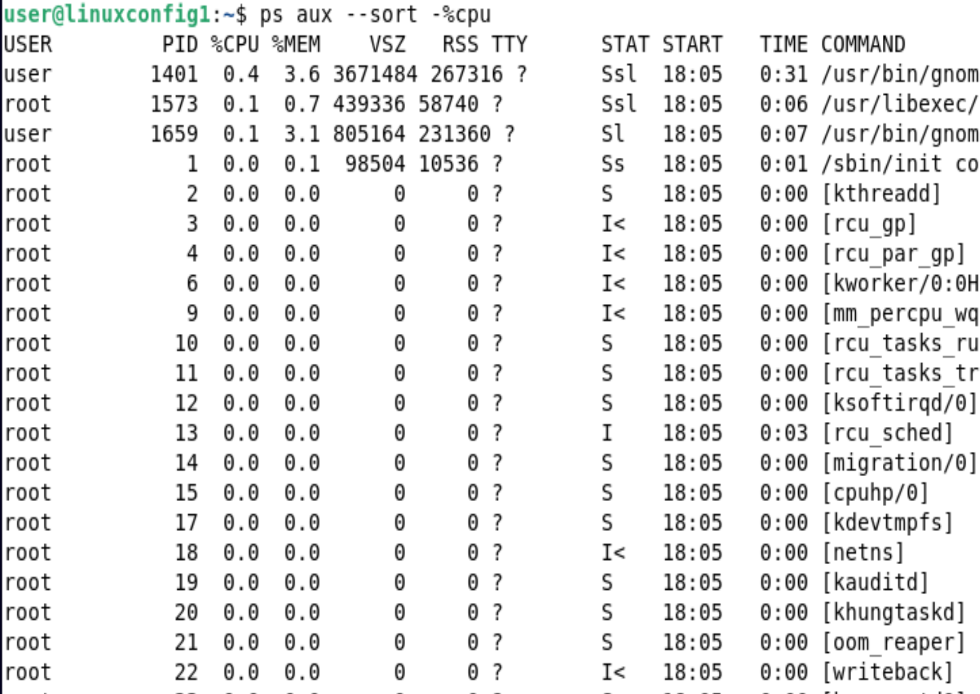

13.

Top -u user

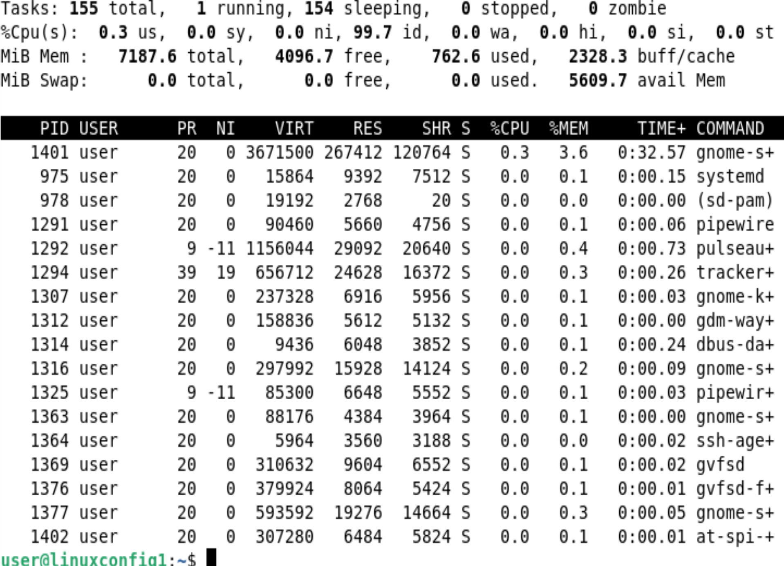

14. PID stands for process identification number.

The command kill -9 kills the application who’s ID number the PID corresponds to.

In this case the ID 2801 is the ID for FireFox.

Therefore by using the kill -9 2801 command, we are killing the firefox app.

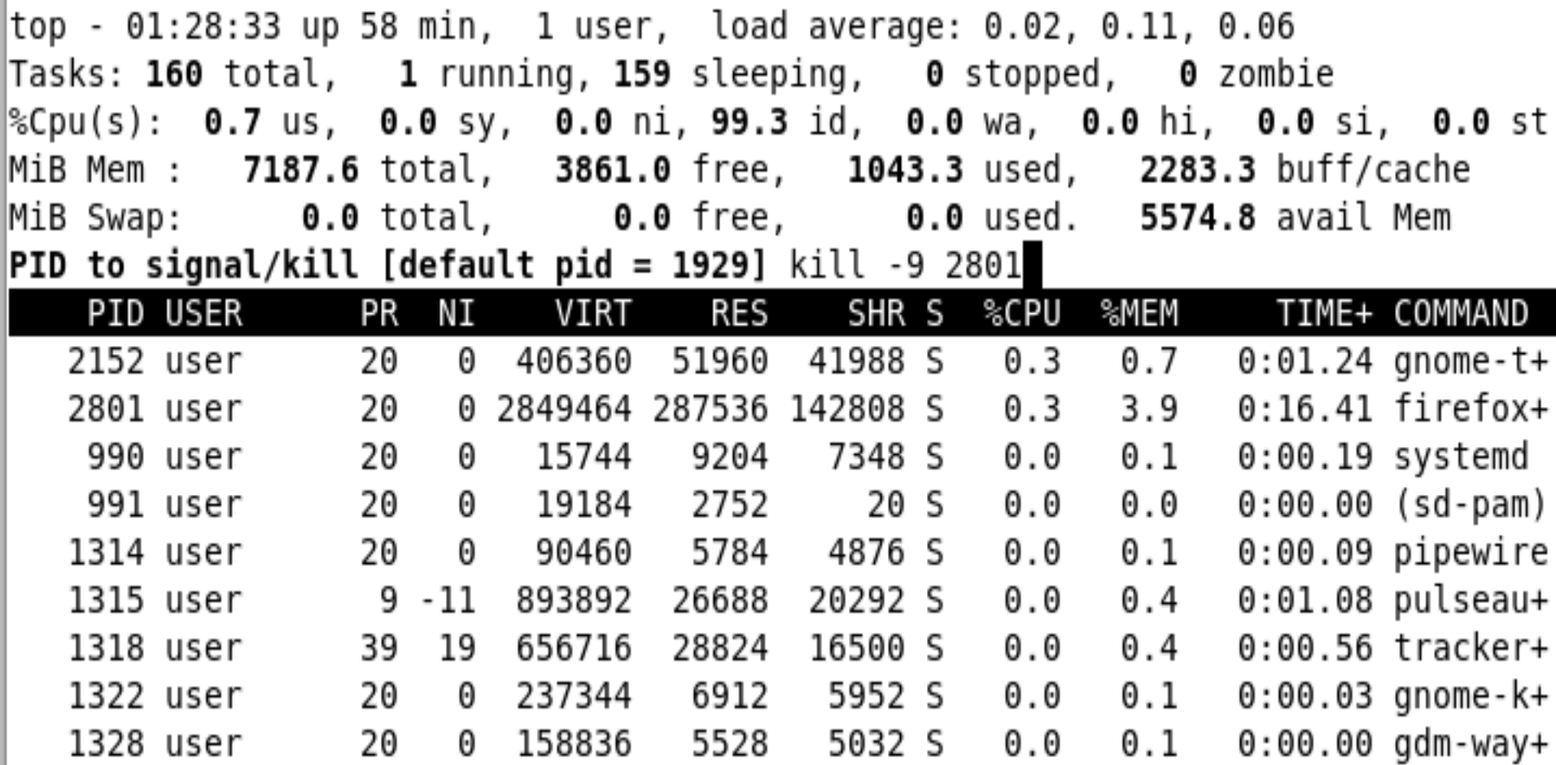



15. The purpose of the type command is to find out how a command that you entered is interpreted

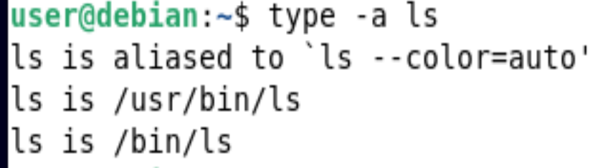

16.

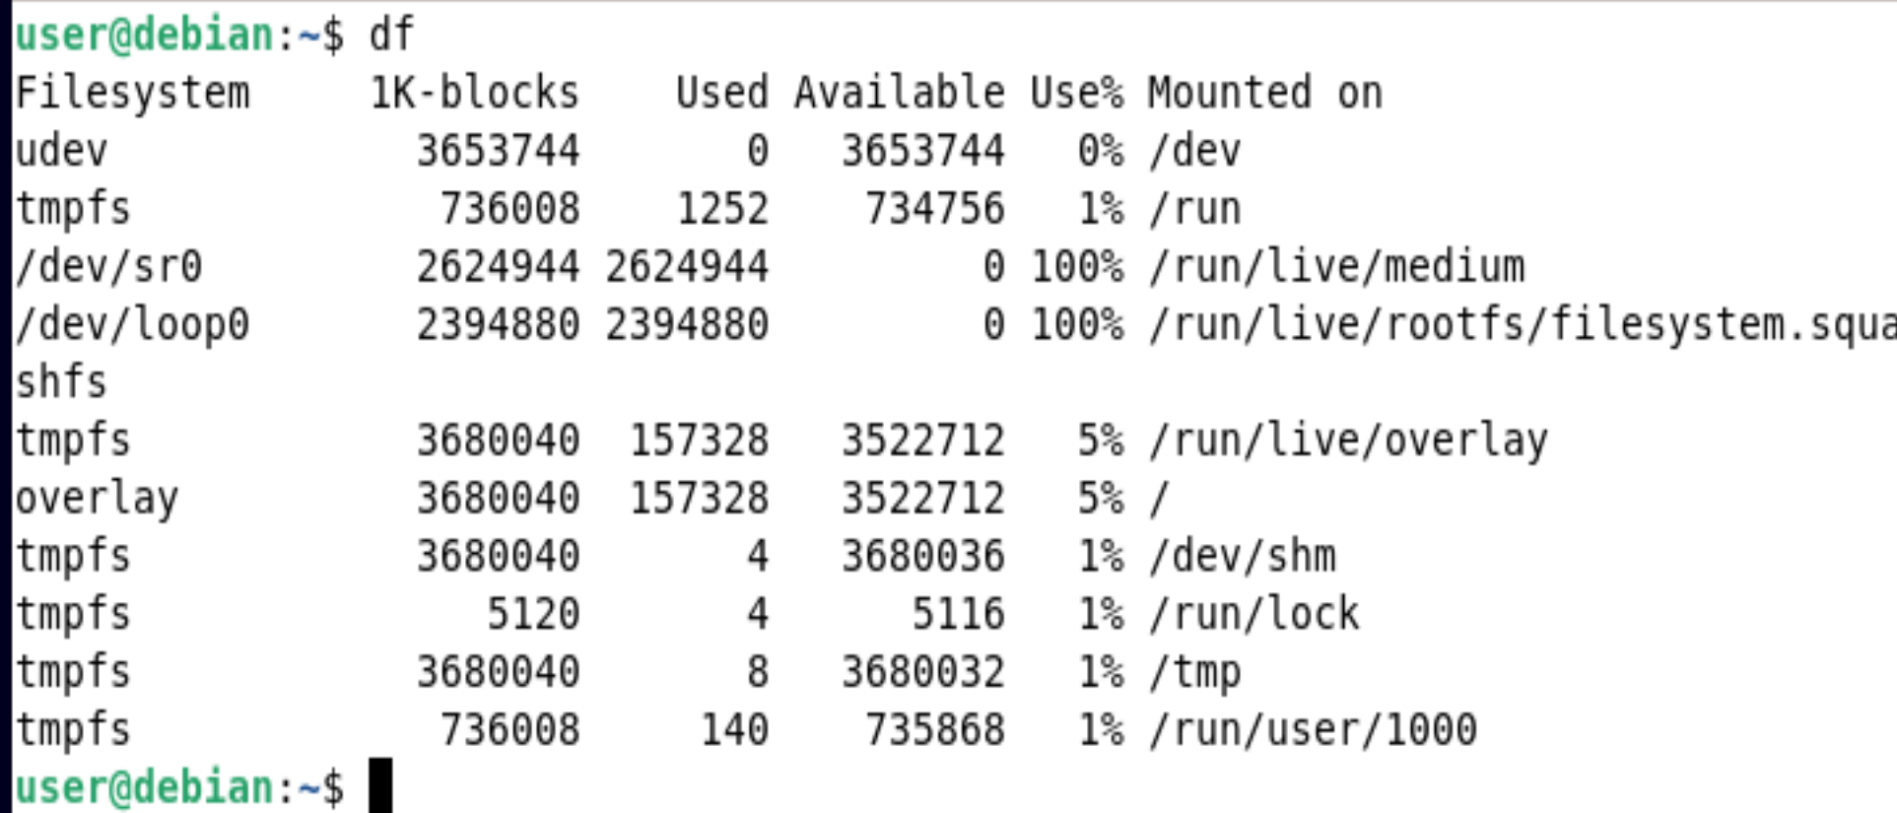

17.

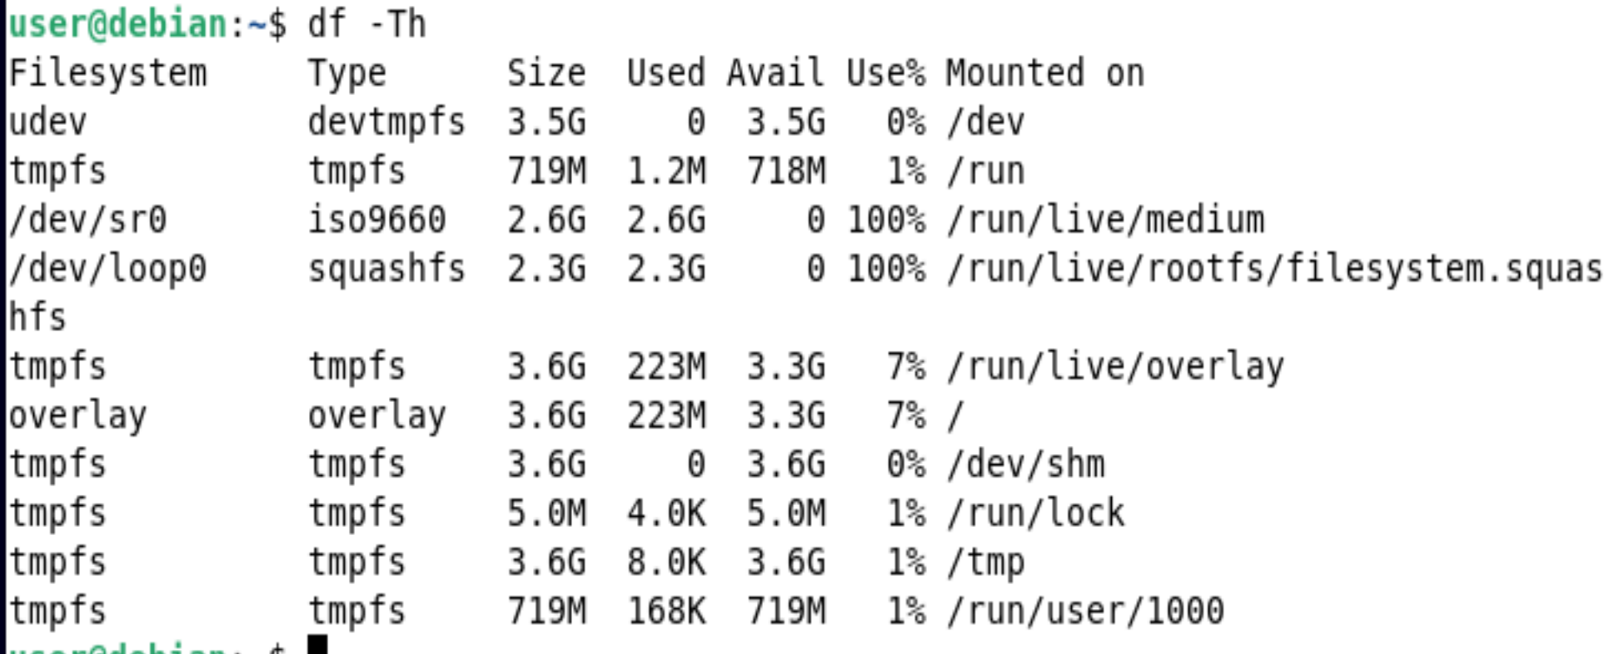

18.

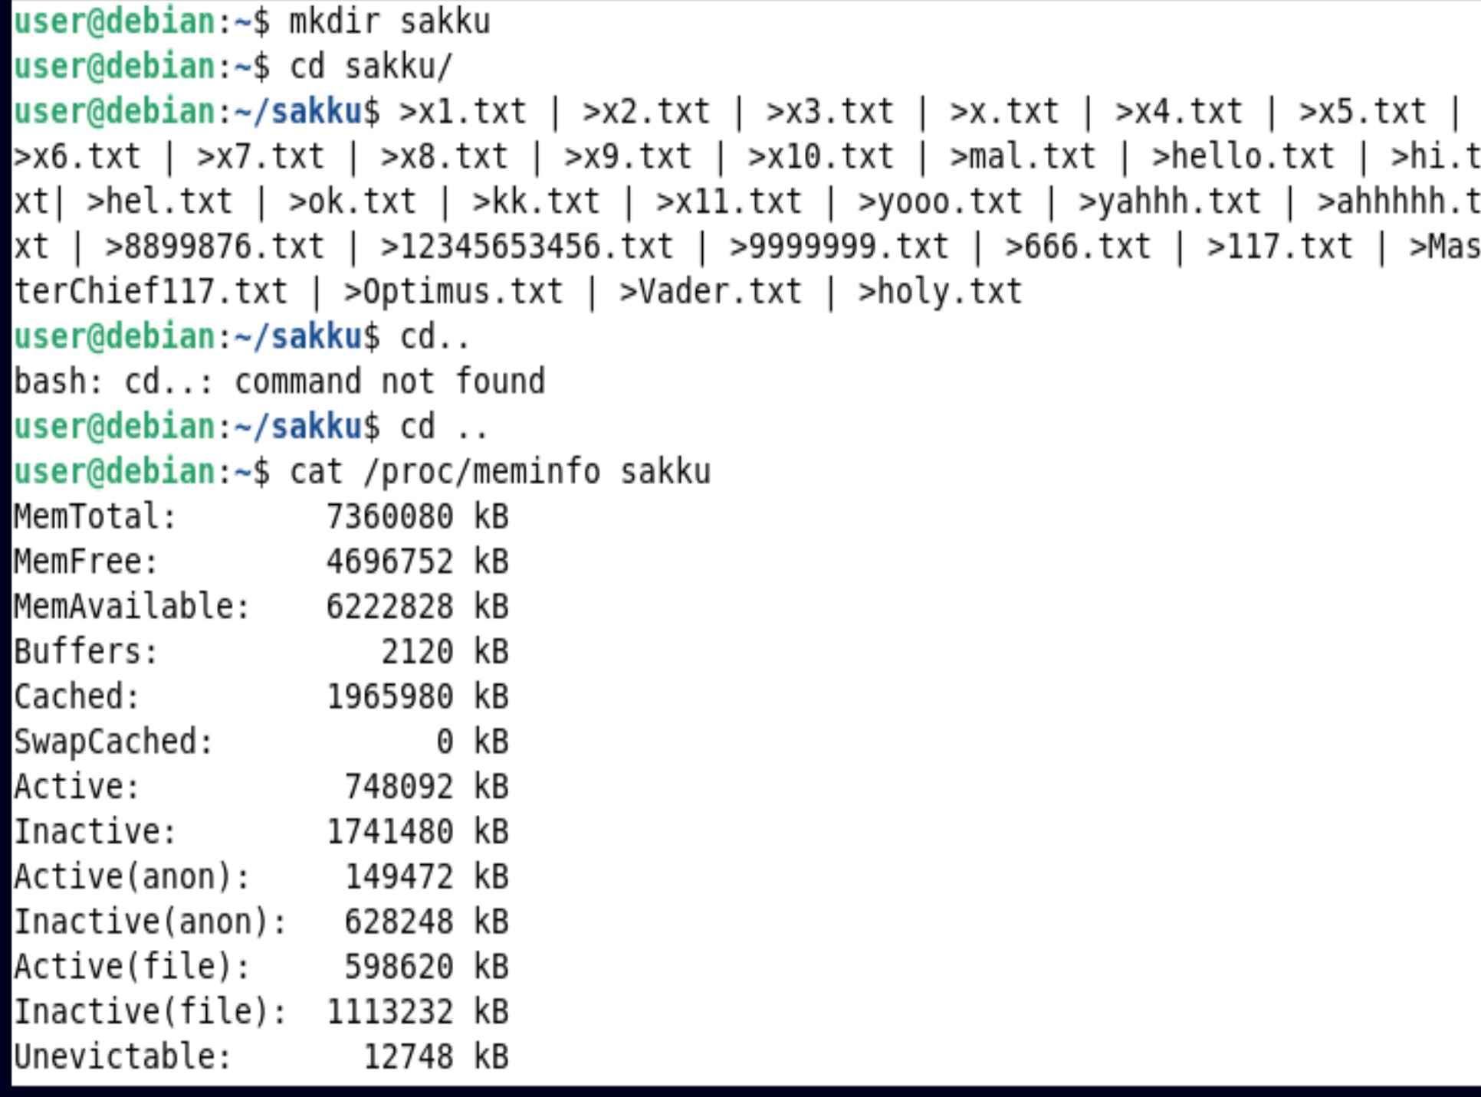 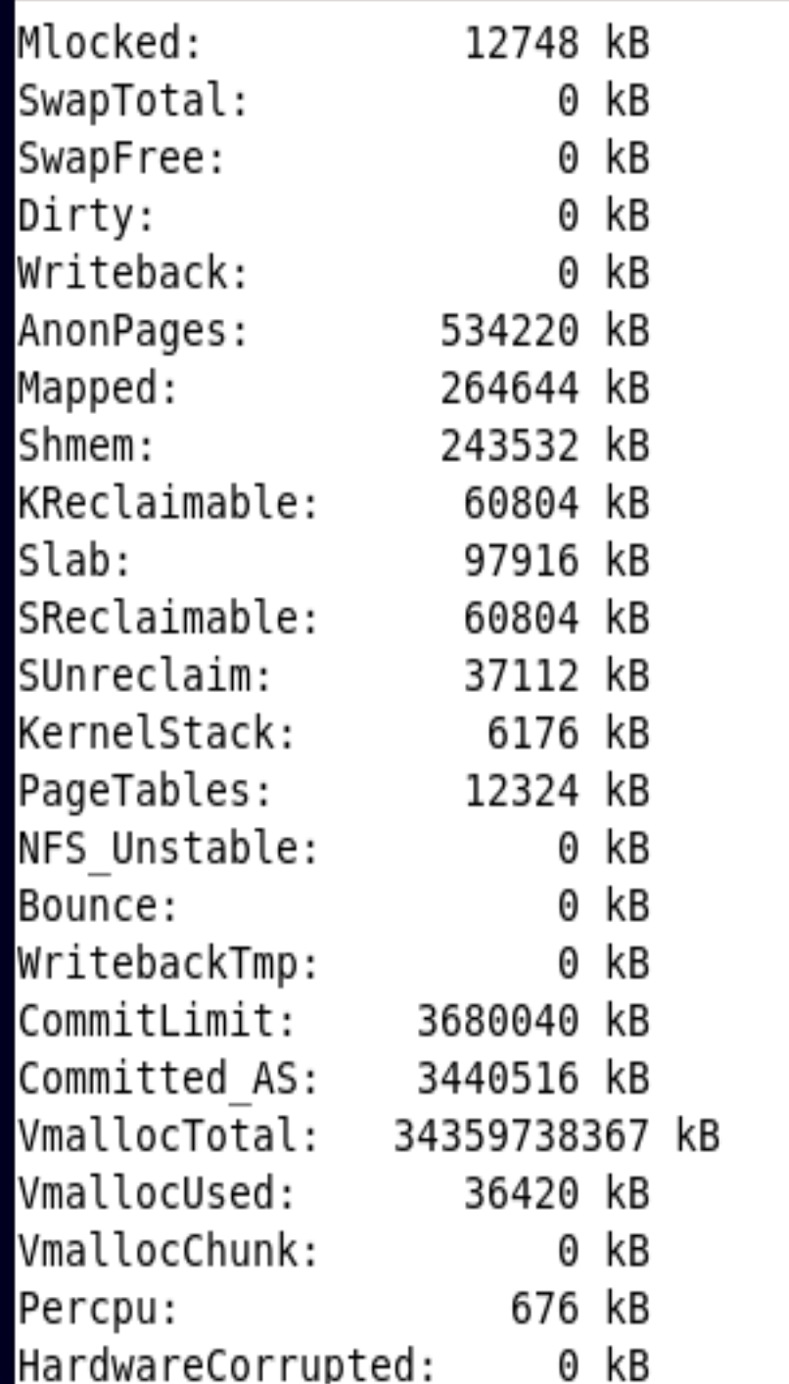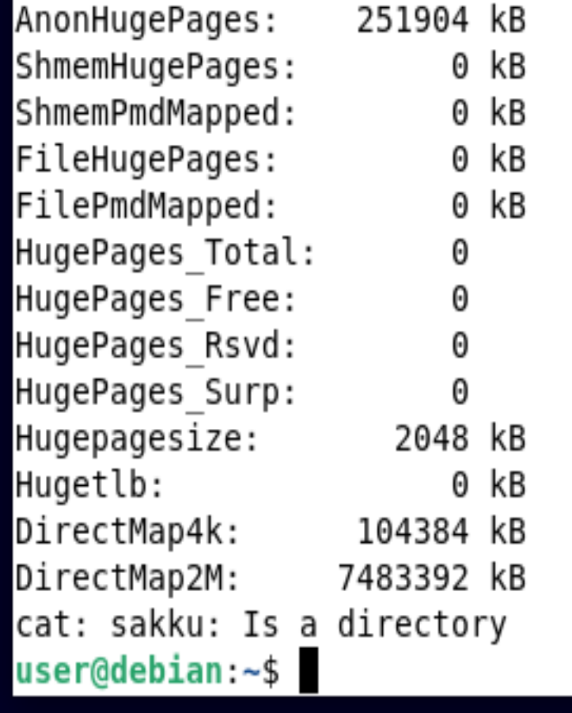

19.

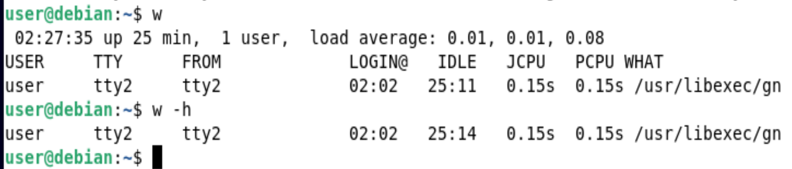

20.

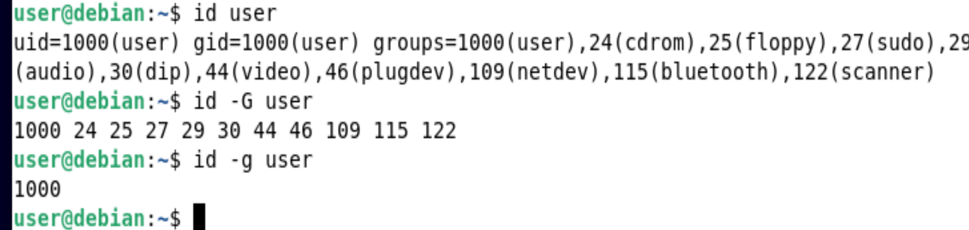

21.

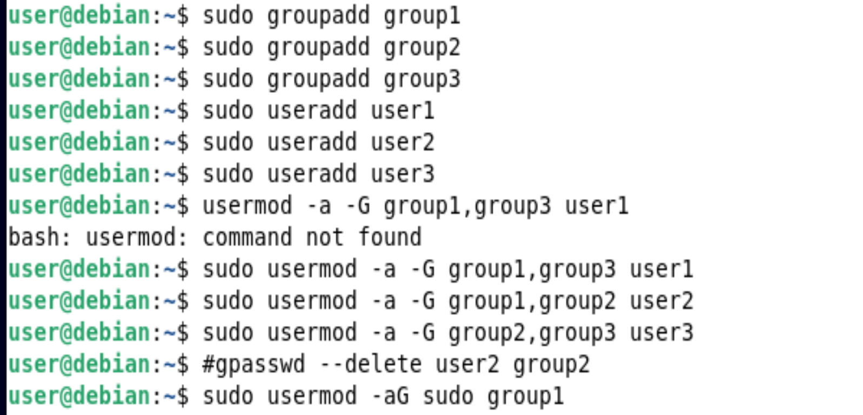

By Using the getent group command I can view which user is in what group

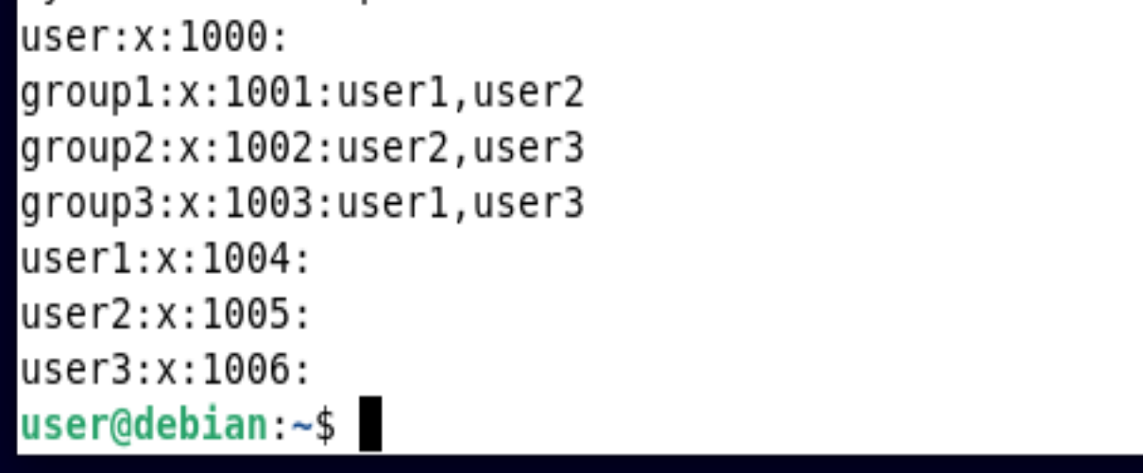

22. The history command shows you the entire list of commands that you have executed

**$history**

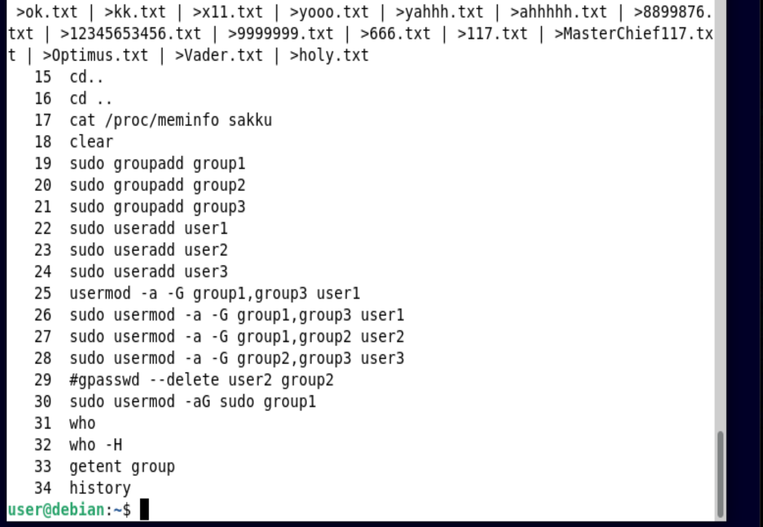

**$history 10**

Shows the last 10 commands that you have used

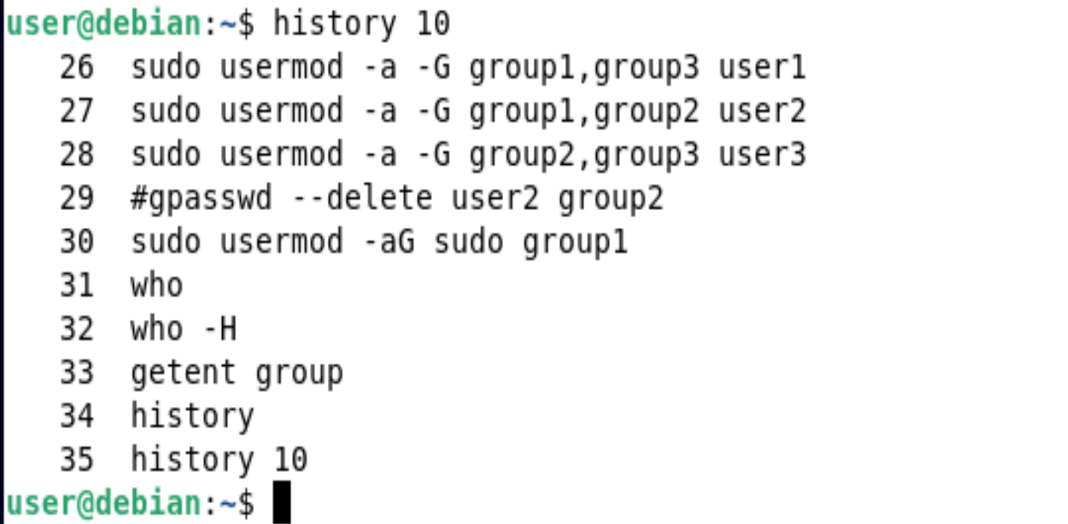

**$history -c**

Removes the whole history of commands

